Project Initialization and Planning Phase

Date | 27 June 2026
Team ID | xxxxxx
Project Name | Credit Card Approval Prediction
Maximum Marks | 3 Marks

Define Problem Statements (Customer Problem Statement Template):

Many people apply for credit cards without knowing whether they meet the bank's approval criteria. Banks evaluate applications using multiple factors such as income, employment status, credit history, and financial background. Manually reviewing each application is time-consuming and may lead to inconsistent decisions. This project aims to develop a Machine Learning model that predicts whether a credit card application is likely to be approved, helping both banks and applicants make faster and more informed decisions.
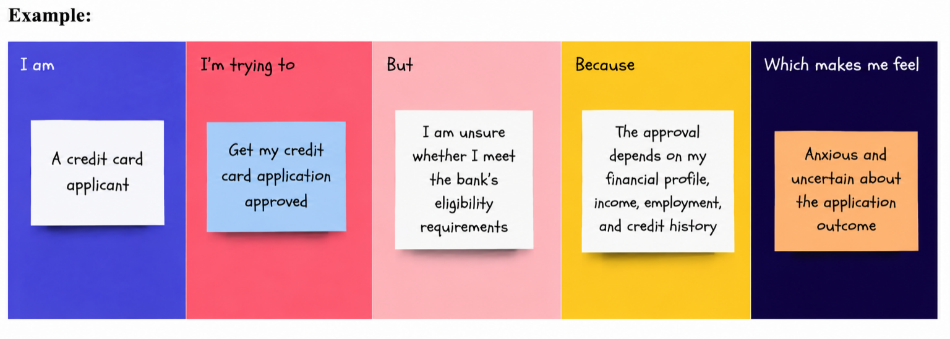

Problem  Statement  (PS) | I am (Customer) | I’m trying  to | But | Because | Which makes me feel
PS-1 | A customer applying for a credit card | Get my credit card application approved quickly | I don't know whether I meet the bank's approval criteria | The approval process depends on many financial and personal factors | Uncertain and worried about whether my application will be approved

